An examination from [Novak et al. (2015)](https://www.frontiersin.org/articles/10.3389/fpsyg.2021.645173/full#B47) on the sentiment of emoji classified emoji into positive, negative and neutral categories. Their results showed that the majority of negative emoji are sad faces, whereas positive emoji did not only consist of happy faces, but also of symbols (e.g., heart, party) as well as objects (wrapped gift, trophy).

**This shows choosing set 2 and set 3, helped us in covering both the positive and negative animojis.**

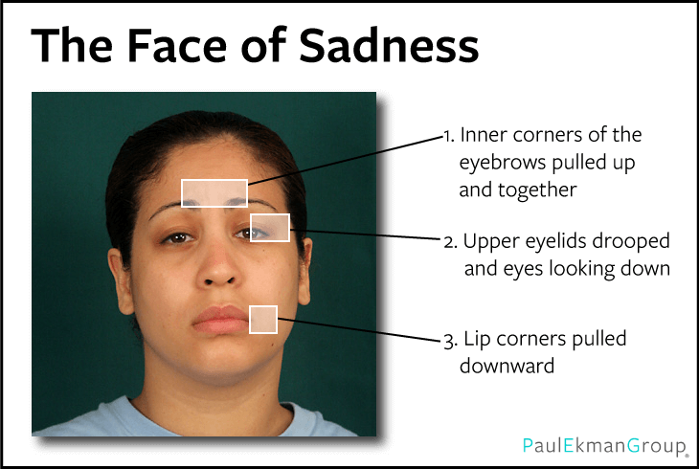

Reference

1. <https://www.frontiersin.org/articles/10.3389/fpsyg.2021.645173/full>
2. <https://journals.plos.org/plosone/article?id=10.1371/journal.pone.0144296>